Streamlining IT Procurement:
Automating Standard Laptop Orders with Flow Designer

Milestone 3 : Service Catalog
Activity 1: Service Catalog for placing order and get Approval
INSTRUCTIONS
- Click on All >> Search for “ Service Catalog ”
- Service Catalog >> click on Hardware.
- Scroll a bit to find the “ Standard Laptop ” click on that.
- After that click on “ Order Now ” to place the request.
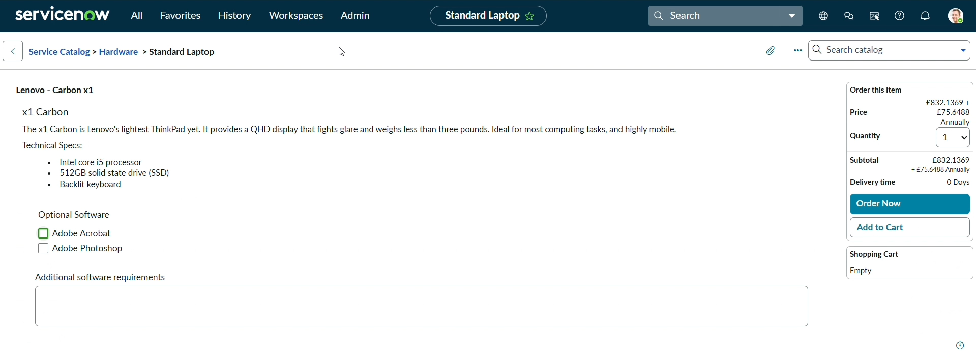
5. Now we will see the Order status
6. In that click on the Request Number
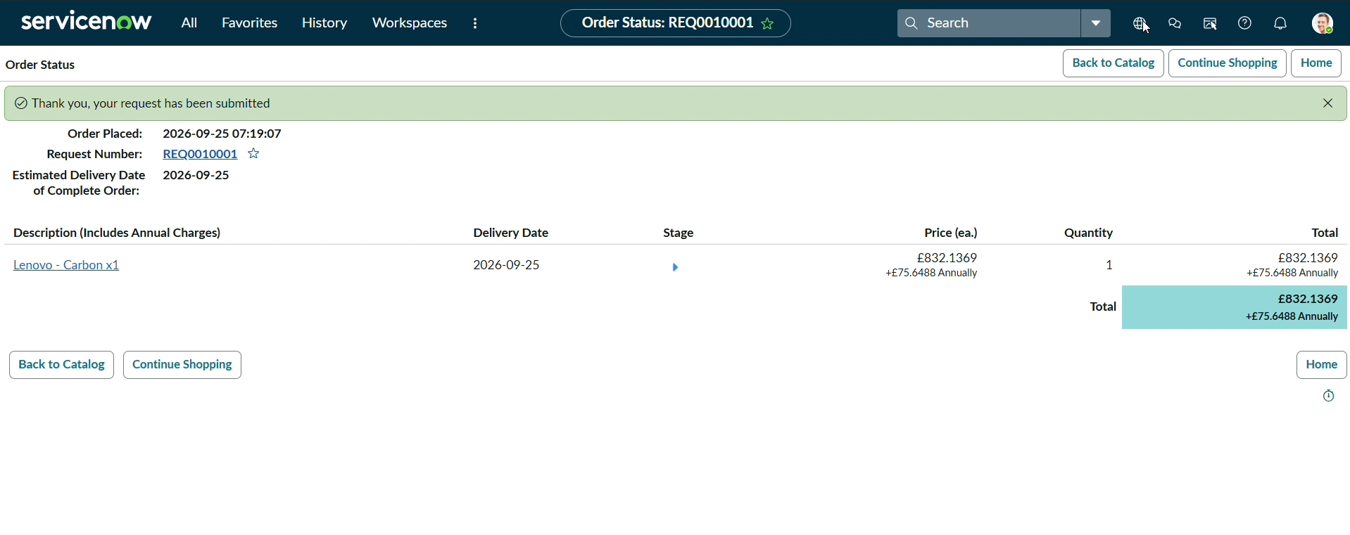

7. It will open the Requested number record.
8. Scroll down Click on the Approvers Section.
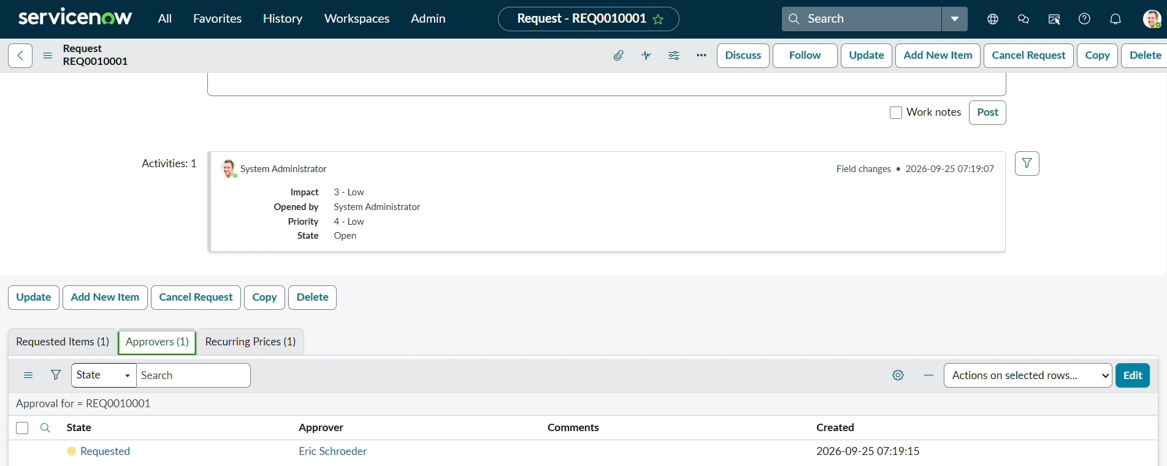
9. Right Click on the Record to see config in that Click on the Approve.
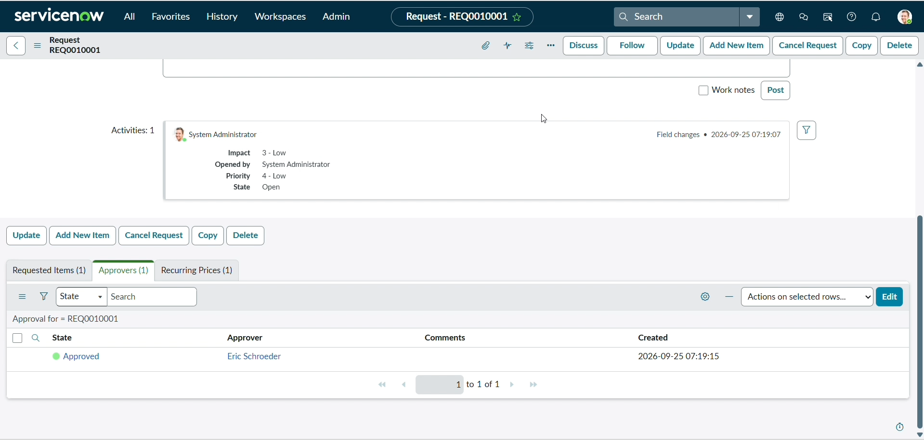
10. Then click on the Requested item Section
11. Open that Requested Item record
12. Scroll down to the “ Catalog tasks ” Section
13. Open the record to see the updated status of the record with Short description and Assigned group.
